Simple Topology Service User Guide
Version 0.5
Late updated on Jan 22, 2015

Simple Topology Service or Cached Topology Service is a service that can pool/cache pre-provisioned and pre-deployed topology instances of applications, such as CLM but not limited to it, for developers, testers, DevOps pipelines, etc. It will save the time for getting an environment or application instance, which traditionally takes hours.
STS is still underdevelopment, so the service and the document are not finalized and are subject to change as we move forward.

Simple Topology Service User Guide 1
What’s new? 2
Signup 2
Sign In 3
Password Reset 4
Providers 5
Pools 6
APP Pool vs. Noapp Pool 6
Define a Noapp Pool 7
Define an App Pool 8
View Instances for a Pool 8
Checkout an Instance 10
Delete an Instance 10
Restful API for Simple Topology Service 11
Authentication for Restful APIs 11

What’s new?
- New user interface
- Simplified pool definition

Signup
Visit the web UI and click Create An Account
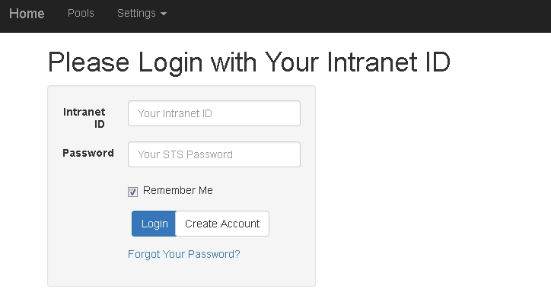
Signup with your intranet id(mail address must end with .ibm.com) and password(not necessarily your intranet password, but a password for the simple topology service).
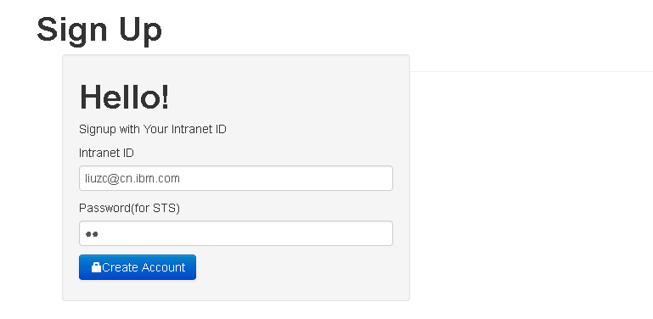
Click Create Account button, you will get a mail for confirmation. Follow the link in the mail to activate your account.
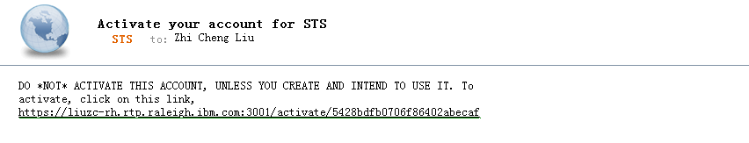

Sign In
Authentication is needed to access all pages of STS. Use your intranet id and password for simple topology service to login.
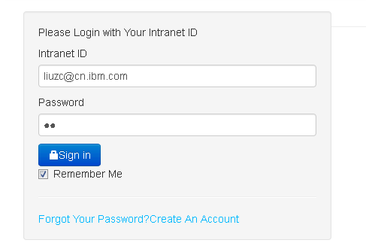

Password Reset
Click on Forgot your password? Reset your password, for your intranet id. You will get an mail to confirm that it is you that would like to reset the password. Follow the link in the mail, and give your new password.
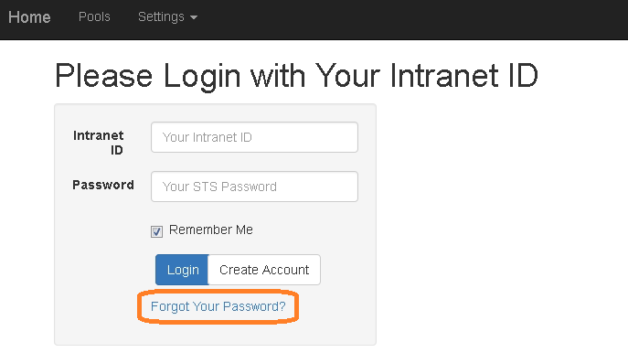
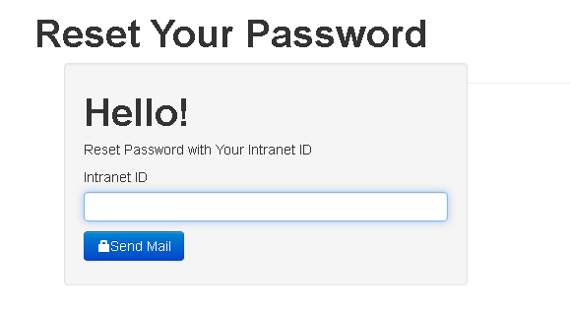

Providers
Providers provide information about UCD instances that your topology will be hosted on.
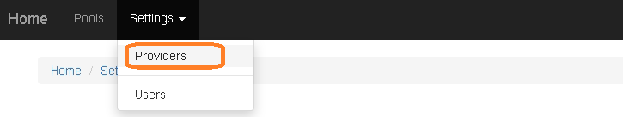
Click on Create a new Provider button to create a new provider. Provide the information for your provider.
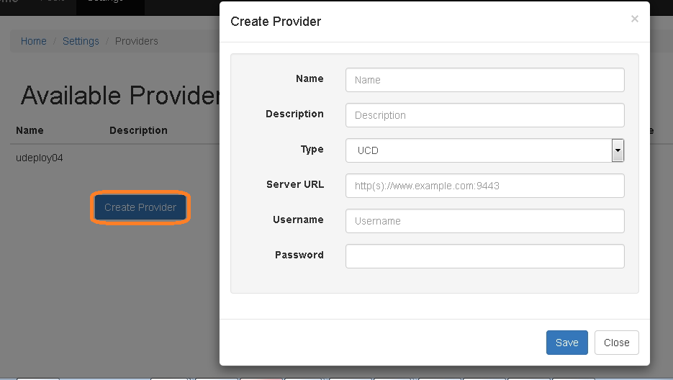

Pools
Click Pools on the navigation bar; it will lead you the pool index page, where you can see a list of available pools, edit, delete or create new ones as you wish.
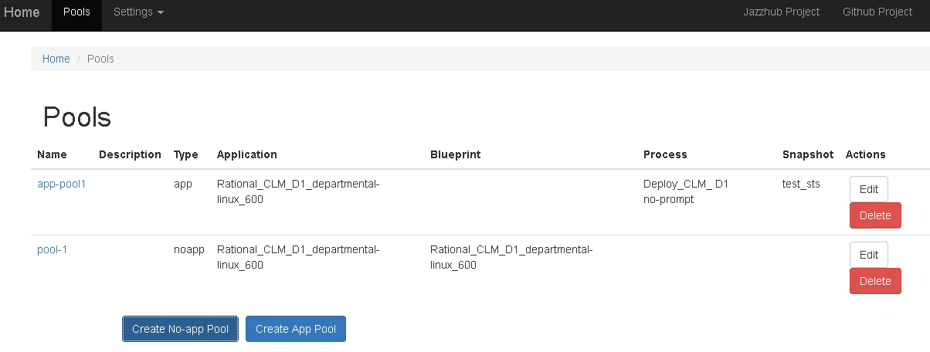

APP Pool vs. Noapp Pool
STS support two types of pools: noapp and app pool. A no app pool will cache a pure environment instance only, which correspond to an environment in UCD and virtual system pattern instance in IWD, without app installed on top of it. Whereas, an app pool instance will have application on top of it.
Application deployment is two-staged in UCD. First, request a environment in UCD, which will take about an hour for a topology like CLM E1. Second, request execution of an application process which will deploy the application in about another hour’s time.
Noapp instances are supposed to save the first hour’s time; and at the same time give users more flexibility on which build or deployment parameters to use. For example, an SVT tester could checkout an instance, and could deploy whatever builds on it with whatever parameter he/she would like to use.
In contrast, app instances serve totally different needs. It could minimize the time needed to get an application instance; users could get it immediately from the system if there are available instances; however it also adds limitation that only recommended/pre-deployed builds and pre-defined parameters could be used in the deployment.

Define a Noapp Pool
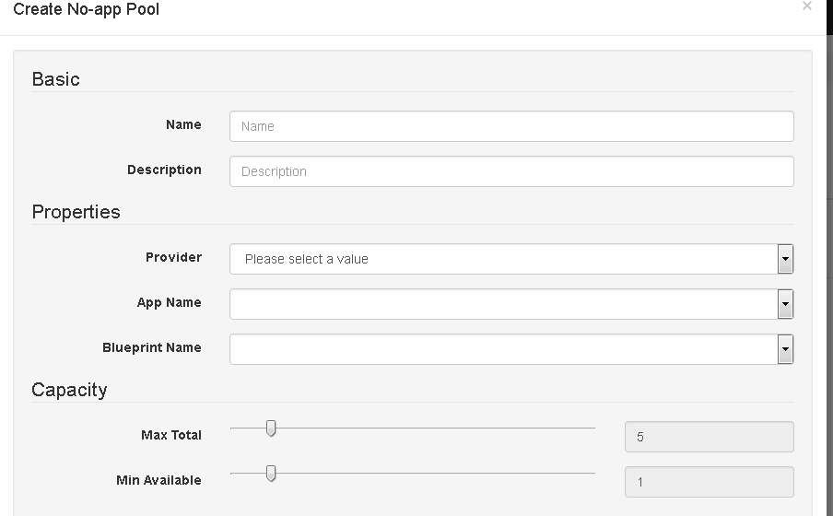

To define a Noapp pool, you need to provide pool name, description, application name and blueprint to deploy the topology, as well as minimum number of available instances for the pool, and maximum total number of instance for the pool.

Note, STS will try to add more instances to the pool when the number of available instances is less than MinAvailable and the total number of instances is less than MaxTotal.

Define an App Pool

To define an app pool, you need to provide pool name, description, and the parent pool, process to deploy the application, process properties, snapshot, as well as minimum number of available instances for the pool, and maximum total number of instance for the pool.

Each app pool is chained with a noapp pool, which we call it the parent pool and from which the app pool could checkout a noapp instance as its environment for deploying the application.

Note, STS will try to add more instances to the pool when the number of available instances is less than MinAvailable and the total number of instances is less than MaxTotal.
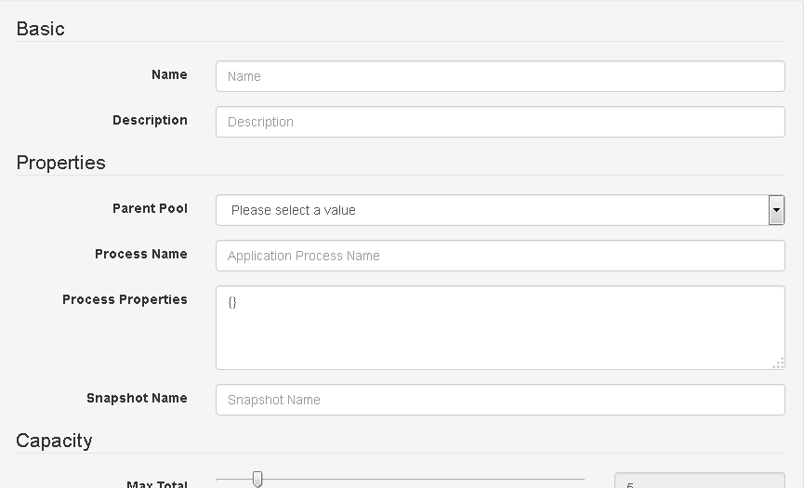

View Instances for a Pool
To view the instances in a pool, you could click the pool name on the pool index page.
You will see something like this:
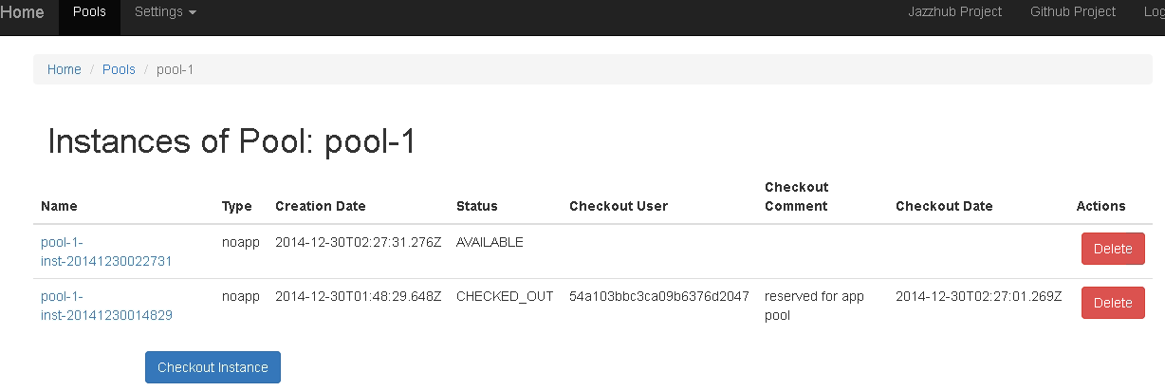

STS will define a name for each of its instance; If you click on the instance name, it will lead you to UCD. For no-app pool, you will be led to resource page of the environment; For app pool, you will be led to process execution log page.
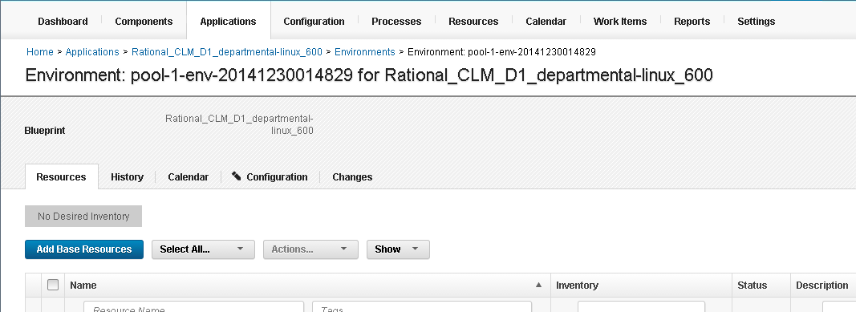
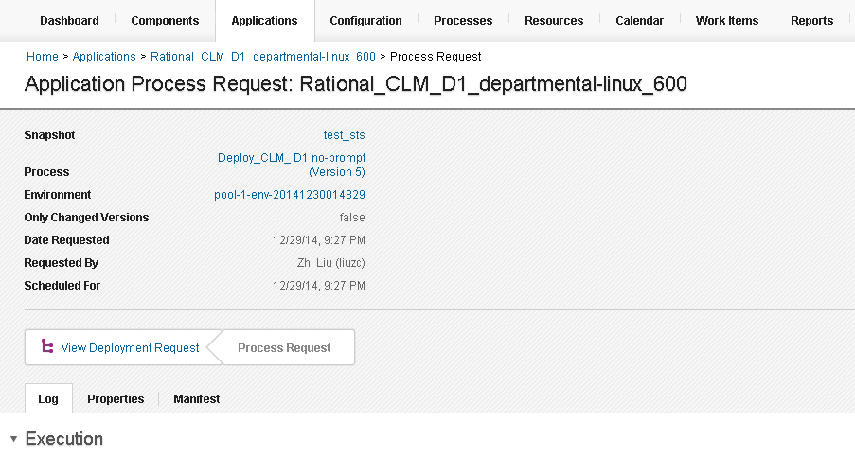

Checkout an Instance
You can checkout an instance if there’s available instance in the pool. You can give a comment for the instance you checkout.
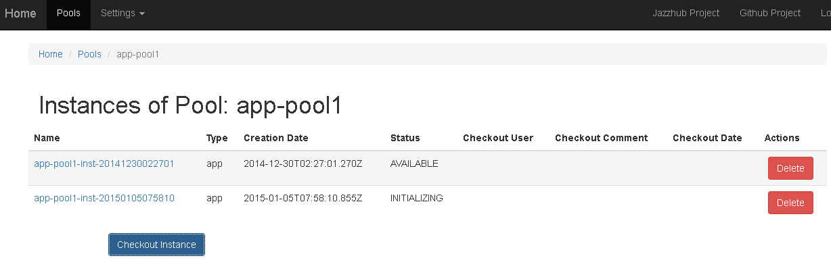

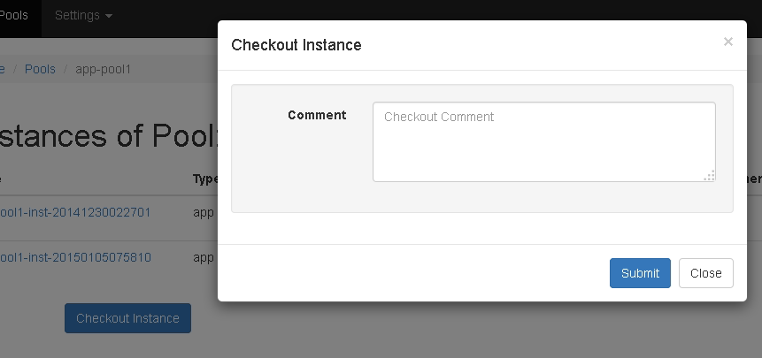

Delete an Instance
When you click delete button to delete an instance, it will be deleted from both pool, app or noapp. And STS will delete the environment in UCD, as well as VSP instance in IWD.

Restful API for Simple Topology Service

STS provide Restful API for integration with other system like continuous test pipeline, etc.

URI | VERB | Sematic | Comment
/api/v1/topology/pools | GET | list
/api/v1/topology/pools | POST | new
/api/v1/topology/pools/:id | GET | get
/api/v1/topology/pools/:id | DEL | del
/api/v1/topology/pools/:id | PUT | update
/api/v1/topology/pools/:id/actions | POST | checkout | See Note#1
/api/v1/topology/pools/:id/instances | GET | list
/api/v1/topology/pools/:pid/instances/:id | GET | get
/api/v1/topology/pools/:pid/instances/:id | DEL | Return instance to pool( delete instance for current implementation)
/api/v1/topology/pools/:pid/instances/:id | PUT | update

Note#1: Use the following example JSON type data in the request body: { type: “checkout”, comment: “Sample comment.” }

Data are exchanged in JSON format. To understand the data models, please refer to the code under directory /models.

Authentication for Restful APIs
Unlike GUI part of the simple topology service, Restful API end points are protected using HTTP basic authentication method. Each API call should provide authentication headers with username and password.

